**Exercise 6**

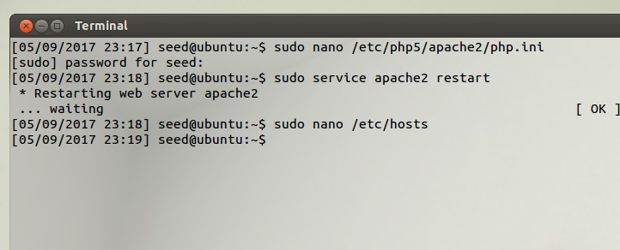

Logged in as User Ted without providing his password.

Username: ted’);#

This is possible because by adding the ‘); we are able to end the code and comment out the rest of the code which ultimately allows us to bypass the password.

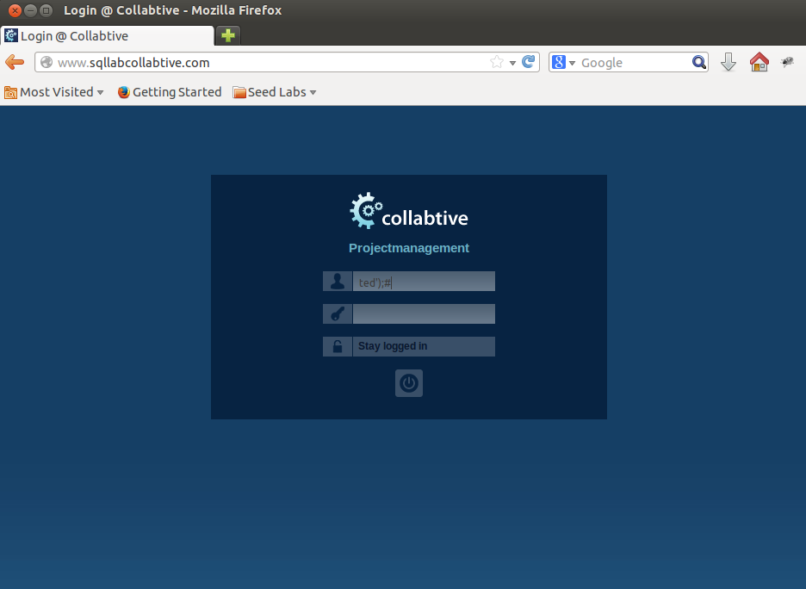

Logged in as User Admin without providing a password.

Username: admin’);#

This is the same for admin.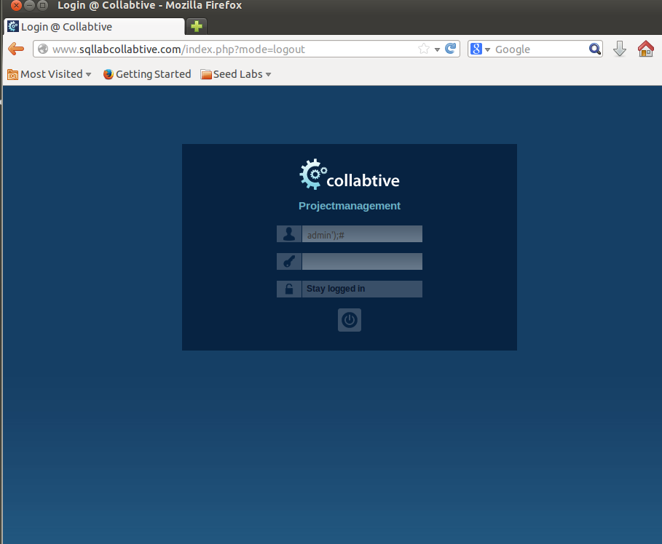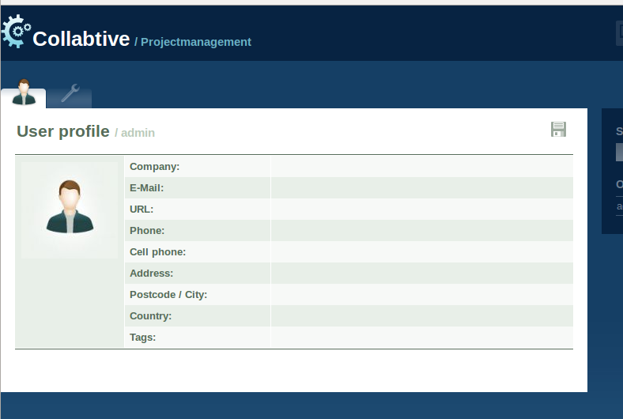

Logged in as a blank username.

Username: ‘ OR name = name);#

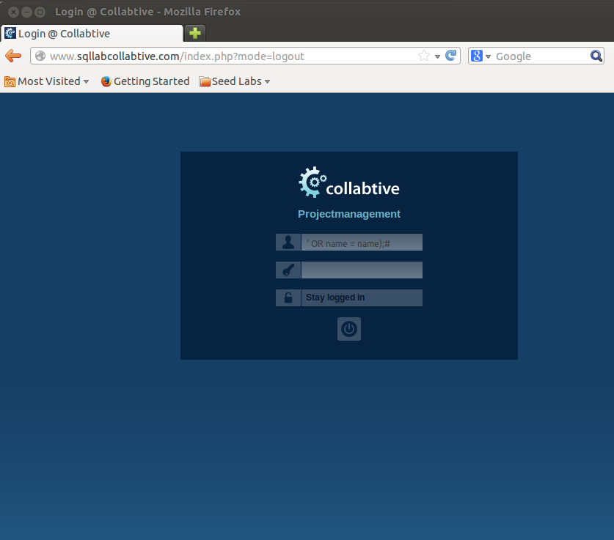Account information shows up as admin.

